**Chapter 6**

**Applications of Integration**

**6.4 Arc Length of a Curve and Surface Area**

**Section Exercises**

**For the following exercises, find the length of the functions over the given interval.**

165. 

Answer:

167. 

Answer: 

169. Find the surface area of the volume generated when the curve  revolves around the from  to  as seen here.

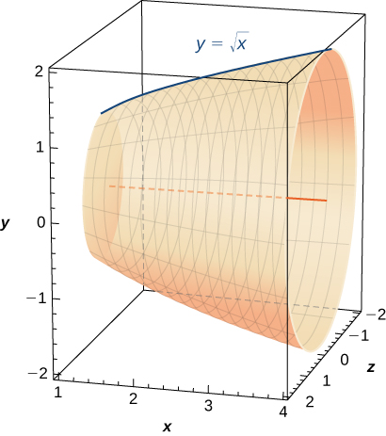

Answer:

**For the following exercises, find the lengths of the functions of over the given interval. If you cannot evaluate the integral exactly, use technology to approximate it.**

171. from

Answer: 

173.  from

Answer: 

175. **[T]** on to 

Answer:

177.  from 

Answer: 

179.  from 

Answer:

**For the following exercises, find the lengths of the functions of  over the given interval. If you cannot evaluate the integral exactly, use technology to approximate it.**

181.  from  to 

Answer:

183.  from to

Answer:

185.  from

Answer:

187. **[T]** from  to 

Answer:

189. **[T]** from

Answer: 

**For the following exercises, find the surface area of the volume generated when the following curves revolve around the *x*-axis. If you cannot evaluate the integral exactly, use your calculator to approximate it.**

191.  from  to 

Answer:

193.  from 

Answer:

195.  from 

Answer:

197.  from 

Answer:

**For the following exercises, find the surface area of the volume generated when the following curves revolve around the *y*-axis. If you cannot evaluate the integral exactly, use your calculator to approximate it.**

199.  from 

Answer:

201.  from 

Answer:

203.  from

Answer:

205. **[T] ** from  to 

Answer:

207. The base of a lamp is constructed by revolving a quarter circle around the  from  to  as seen here. Create an integral for the surface area of this curve and compute it.

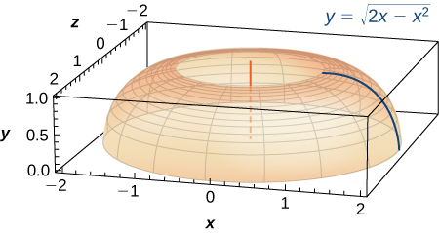

Answer: 

209. **[T]** A lampshade is constructed by rotating  around the  from to  as seen here. Determine how much material you would need to construct this lampshade—that is, the surface area—accurate to four decimal places.

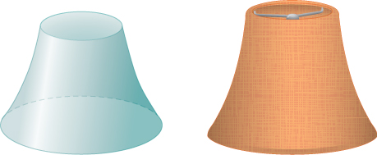

Answer:

211. **[T]** You are building a bridge that will span  ft. You intend to add decorative rope in the shape of  where  is the distance in feet from one end of the bridge. Find out how much rope you need to buy, rounded to the nearest foot.

Answer: ft

**For the following exercises, find the exact arc length for the following problems over the given interval.**

213. Draw graphs of  and  For as  increases, formulate a prediction on the arc length from  to  Now, compute the lengths of these three functions and determine whether your prediction is correct.

Answer:

215. Solve for the length of  from Show that  from  to is twice as long. Graph both functions and explain why this is so.

Answer: Answers may vary

217. Explain why the surface area is infinite when  is rotated around the  for  but the volume is finite.

Answer: For more information, look up Gabriel’s Horn.

This file is copyright 2016, Rice University. All Rights Reserved.